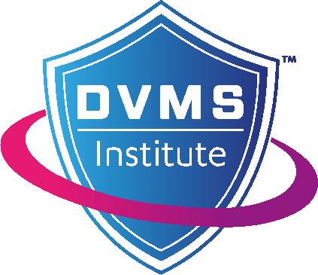
NCP 010
DVMS Cyber Resilience Professional
Foundation Syllabus

Version 4.0  August 2025 | 

Contents
Introduction 3
NIST Cybersecurity Professional Foundation Syllabus: 4
Examination Design and Administration 6
Duration: 6
Number of questions: 6
Level of knowledge: 6
Delivery: 6
Format: 6
Scoring: 6

Introduction
This document provides the course learning outcomes and assessment criteria. It also provides an overview of the examination design, including the types of questions asked.
This syllabus provides the number of marks appearing on the exam and Bloom’s Taxonomy level of the questions (levels 1 and 2 – knowledge and comprehension).

NIST Cybersecurity Professional Foundation Syllabus:
The table below provides the information necessary to complete the course, demonstrate mastery of the learning outcomes, and prepare for the certification exam. The reference column contains location information of the associated source material.
The Reference column refers to sections in the book Fundamentals of Adopting the NIST Cybersecurity Framework 2nd Edition. The letters “ff” following a book section (e.g., 4.1ff) means that this section and all subsections are examinable. When the Reference column contains “Module x slides” it means the examination questions for this section are drawn from the slides and instructor comments about the material.

Ref. # | Chapter | Learning Outcomes | Reference | Marks
1.0 | Module 01  Imperative & Origin | - Explain the concept of risk.  - Understand the difference between a threat and vulnerability.  - Understand cybersecurity risk.  - Understand the NIST-CSF timeline.  - Explain the benefits of adopting the NIST-CSF |  | 2 marks
1.1 | Imperative |  | 1.2, 2.0, 2.2, 2.2.2. 3.0
1.2 | Origin |  | 4.0 (including Figure 4.1 and Table 4.1)
2.0 | Module 02 Framework Structure | - Explain the structure of the NIST-CSF Core  - Understand the concepts of profiles and tiers  - Understand the relationship between CSF Profiles and CSF Tiers  - Understand the use of the NIST-CSF online reference | 4.1, 4.2, 4.3, 4.4 | 8 marks
3.0 | Module 03  Framework Core | - Understand the structure of the NIST-CSF Core  - Describe the high-level outcomes of the CSF core  - Understand the high-level objectives of the CSF Core categories | 4.1ff | 6 marks
4.0 | Module 04  CSF Profiles & CSF Tiers | - Understand and describe the use of CSF Profiles  - Understand and explain CSF Tiers and their use | 4.2ff, 4.3 (including Figures 4.4, 4.5, and 4.6), Appendix A | 6 marks
5.0 | Module 05  COSO Enterprise Risk Management | - Understand the COSO 20 principles in the context of adapting a NIST-CSF  - Understand how culture impacts an organizational risk | 3.1ff | 2 marks
6.0 | Module 06  NIST CSF & NIST Privacy Framework | - Describe the role of a privacy framework  - Understand how an organizational Privacy Framework is integrated with the NIST-CSF | Module 6 slides | 2 marks
7.0 | Module 07  NIST-CSF and Resiliency | - Understand the importance of organizational resiliency in the context of the NIST-CSF | Module 7 slides | 2 marks
8.0 | Module 08  Adopt and Adapt the NIST-CSF | - Describe the strategic importance of adopting the NIST-CSF  - Describe senior leadership’s role in adopting the NIST-CSF:  - Commitment  - Curate culture  - Describe what it means to adopt a framework  - What is the organizational commitment when adopting the NIST-CSF? | Module 8 slides  Book 4.5ff, 6.1ff, | 5 marks
9.0 | Module 09  Adopt the NIST-CSF | - Explain what a NIST-CSF Informative References is  - Describe how an organization adapts IR controls to suit its needs  - Describe how adapting and implementing the informative reference controls will improve organizational resiliency | Module 9 slides  Book 4.4, 6.2ff | 3 marks
10 | Module 10  Beyond the Framework | - Understand the DVMS overlay concepts.  - Explain the DVMS Z-X Model seven capabilities.  - Explain how the DVMS overlay is used to identify performance gaps.  - Understand the application of the DVMS FastTrack™. | Module 10 slides  Book 3.4, 5.2ff, 5.3ff | 4 marks

Examination Design and Administration

Duration:
60 minutes

Number of questions:
40

Level of knowledge:
Bloom’s level:
1 – Knowledge
2 – Comprehension

Delivery:
Paper-based, proctored classroom
Online, proctored

Format:
The exam is “closed book” with forty (40) multiple-choice questions, each with a single correct answer from 4-choices (A, B, C, D).
Questions may appear in the following forms (sample, not an exhaustive list).
- Which of the following is true, correct, most correct?
- Which of the following statements is NOT correct?
- Which of the following statements addresses X?
- How would you show Y?
- What is…?
- What is missing from…?
- _____ is a correct way to…?
- How would you describe…?
- How would you explain…?
- What is the main idea of…?
- Which is the best choice…?

Scoring:
Each correct answer is worth 1 point. Passing is 60% (24 correct answers out of 40).

